Web Design Document
for
Mobile Developers Institute

Site Goal: Provide information about the Mobile Developers Conference which will result in 95% of all sites being sold.

Audience: Our audience is web and application developers interested in marketing to mobile users.

Desktop and Phone Wireframe: This shows a typical page for desktop and smart phone display.

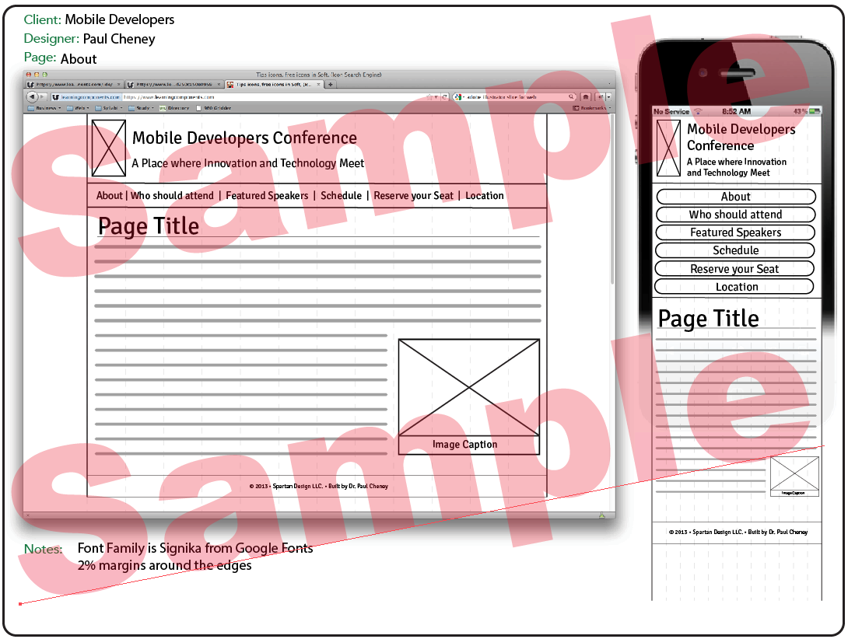

Site Map: All pages on this site will be accessible from the main navigation bar except the signup confirmation page. Tis page will automatically redirect to the main page after 5 seconds using a refresh meta tag.
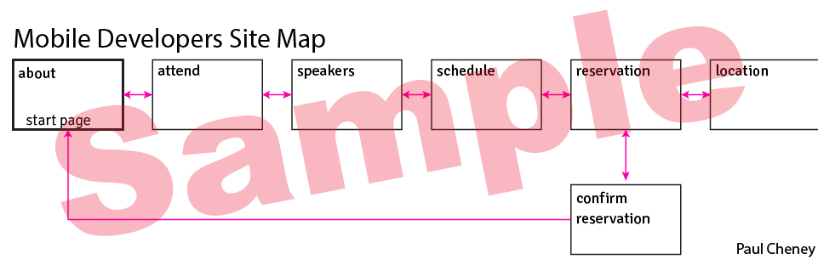

Kuler Color Scheme: These colors are serious, professional. They are all very dark so I will have to create some lighter versions of some of them for the client.
